

Directions: Factor the following polynomials. DNF (Does Not Factor) is not an option!



1. ___________________________________

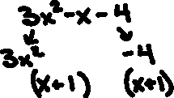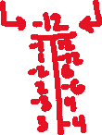

1. _________________________________

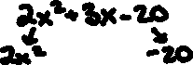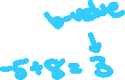

1. __________________________________

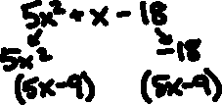

1. __________________________________

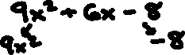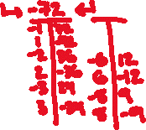

1. _________________________________

